CNA 426/526: Computer Networking II
Fall 2011
Instructor: Dr. Tirthankar Ghosh
Exercise

Problem 1:
A router B receives an updated routing table from another router A. The updated routing table from A and the initial routing table at B are shown below. Assume that the routers run RIP (distance vector), what will be the new routing table at B?

Updated routing table from A Initial routing table at B
Destination | Delay metric | Next Hop
B | 8 | B
C | 7 | C
D | 12 | B
E | 9 | C
G | 10 | C
Destination | Delay metric | Next Hop
A | 7 | A
C | 10 | A
D | 4 | D
E | 12 | F
F | 9 | F

Problem 2:

A network is represented below. Find the least cost paths from node A to all other nodes using Dijkstra’s algorithm. Draw the routing table at A.

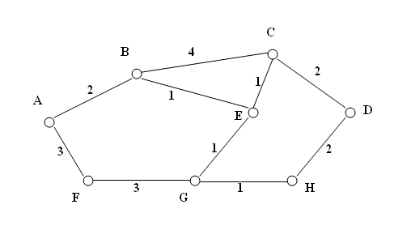
Problem 3:
- An organization is given an IP address 23.240.0.0/16. The organization has 10 departments, each of which should be formed into a separate subnet. The IP address should be extended to accommodate separate IP addresses one for each subnet. What will be the extended network prefix? Write down the IP addresses of the first 5 subnets both with and without IP subnet zero. What will the broadcast IP address of the first subnet in each case?
- The first subnet was assigned to the Marketing department of the organization. The department wants to create 10 more subnets, each for one of its 10 subdivisions. What is the extended mask? What are the subnet addresses of these subnets?

Problem 4:
- A block of addresses is granted to a small organization. We know that one of the addresses is 51.49.128.24/24. What are the first and last addresses in the block? How many addresses can we have in the block?
- A block of addresses is granted to a small organization. We know that one of the addresses is 51.49.128.24/26. What are the first and last addresses in the block? How many addresses can we have in the block?

Problem 5:
- In an IPv4 packet, the value of HLEN is 1111 in binary. How many bytes of options are being carried by this packet?
- In an IPv4 packet, the value of HLEN is 1001 in binary. How many bytes of options are being carried by this packet?
- In an IPv4 packet, the value of HLEN is 5, and the value of the total length field is 0x00c2. How many bytes of data are being carried by this packet?
- In an IPv4 packet, the value of HLEN is 5, and the value of the total length field is 0x004b. How many bytes of data are being carried by this packet?

Problem 6:
- An IPv4 packet has arrived in which the fragmentation offset value is 0, the value of HLEN is 5, and the value of the total length field is 1300. What are the numbers of the first byte and the last byte?
- An IPv4 packet has arrived in which the fragmentation offset value is 120, the value of HLEN is 5, and the value of the total length field is 1200. What are the numbers of the first byte and the last byte?

Problem 7:
Convert the following multicast IP addresses to the corresponding Ethernet multicast physical address:
- 230.43.14.7
- 225.50.41.128
- 229.55.14.7
- 229.60.15.220

Problem 8:
In a TCP session between two hosts, the receiver window size is 15. What is the size of the sender window? The receiver shrinks its window size by 5. What are the new receiver and sender window sizes?

Problem 9:
(a) In a TCP session between two hosts, the sender sends three successive segments and records the RTT as 10, 12 and 9 msecs respectively. The initial RTT before sending the first segment was 15 msecs. Calculate the Retransmission Timer after the receipt of the third acknowledgement.

(b) In the problem above, if the second segment is lost and has to be retransmitted, what will be the Retransmission Timer after the receipt of the third acknowledgement?

